**ER-Diagram Hotel Management System**

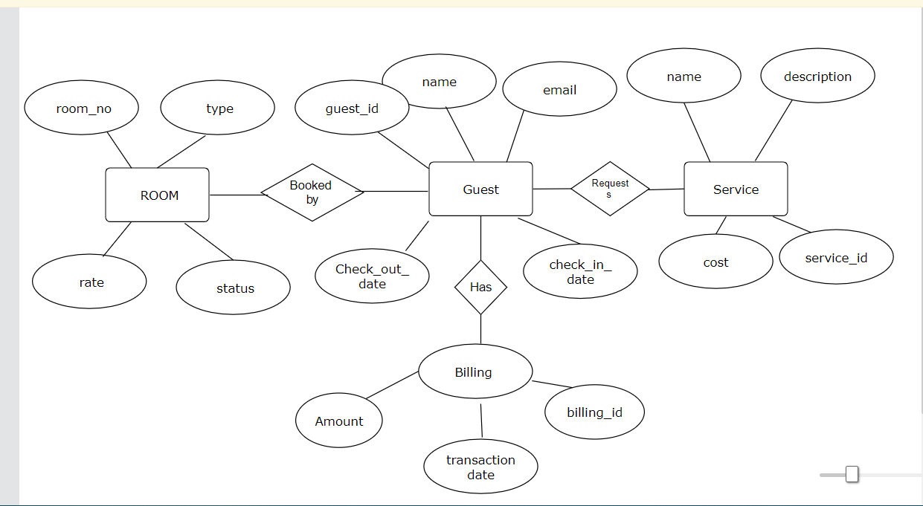

**Note:-**

Relationship between Entities:-

1. Room--------Guest (One to Many).

2.Guest---------Room(Many to one).

3.Guest--------Service(One to Many).

4.Service------Guest(Many to One).

5.Billing------Guest(Many to One).